## Happy Workflow

1. User will register with EasyEMI
   1. User will register with EasyEMI by providing required information like KYC Docs, Financial, Social
   2. Above information with gathered in step wise with validation
   3. In decision system, this information will used to define score on top of credit score, which will add more value and get most suitable and cheap loan option
2. User will go clearTrip.com
3. Book the flight and go ahead with payment
4. Payment page will show the cardless loan option
5. After selection of that option, user needs to validate the EasyEMI registered mobile number with OTP
6. After validating enter mobile number with the OTP, user will see recommended tenure option for the ticket booking amount
   1. Based on the score and other attributions generated decision system, loan recommendations has been served
   2. The waterfall approach will help to get best possible loan option with respective of score
7. User will confirm the payment option by validating the OTP
8. User will ticket booking receipt and invoice with installment details (or underwriting docs)
9. Happy users get loan without any collaterals
10. Lender get a new customer or retain the existing customer
11. Consumers able to sell more ticket with guaranteed money
12. Merchants makes money via service fee

How do we track payments against installments?

1. Is there any way to track down payments against installments?
   1. If yes, then set up a rewards system against each successful payment against installment
   2. Use those rewards credits against coupons
2. If ans. is no, then stick with loyalty program for reward system

What happens when users cancel booking? (!!!)

1. If user cancel the booking then based on consumer refund policy, new transaction will be behalf of the user via consumer
2. Don’t know how to charge a user for cancellation fees
   1. Will be considered as installment
   2. Or one time payment
3. If there is no cancellation fee, then reverse the underwriting process or nullify the loan agreement
4. Send a communication to user with details

EasyEMI admin panel can help you to do following things

1. Rules are configurable , you can add them as service
2. You can set a system according to country’s rules and regulations like GDPR, PCI
3. Note: There will be multiple merchants and lenders which works differently with country’s rules and regulations
4. You can different set of micro services like for Data Validator, Enricher and collectors

## 

## **Architecture**

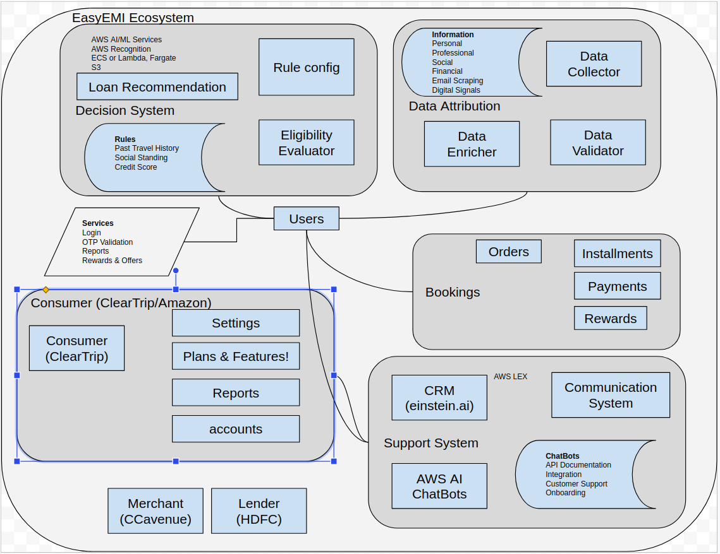

## Tech Stacks

**EasyEMI Site**

<https://vuetifyjs.com/en/introduction/why-vuetify/>

Python (aws lambda) serverless Or PHP

MongoDB / DynamoDB / Firebase / <https://vitess.io/> (Need clear picture of Entities)

CloudWatch Xrays, CloudWatch Logs (ELK or logz.io as Secondary system), CloudWatch Events, Insights , CloudAlarm, CloudFormation, AWS CodeStar (CI/CD)

**EasyEMI Admin Panel**

<https://www.creative-tim.com/product/vuetify-material-dashboard>

Python (aws lambda) serverless Or PHP

MongoDB / DynamoDB / Firebase / <https://vitess.io/> (Need clear picture of Entities)

CloudWatch Xrays, CloudWatch Logs (ELK or logz.io as Secondary system), CloudWatch Events, Insights , CloudAlarm, CloudFormation, AWS CodeStar (CI/CD)

**Decision System**

will served as following microservices

1. **Rules Config service** which initialise country based rules configuration (merchants, leanders)
2. During the onboarding process of the user, all required information will collected and used as input for next micro service
3. **Eligibility Evaluator** service which does the gamification using provided input information and add more weightage to credit score
4. **Loan Recommendation** service which gives the best possible tenure / loan options by checking stored credit score if required it also does runtime rule evaluation for specific cases by coordinating with **Eligibility Evaluator** service

Golang (https://gosparta.io/) / Python (https://github.com/aws/chalice) / nodejs

MongoDB / DynamoDB / Firebase / <https://vitess.io/> (Need clear picture of Entities)

CloudWatch Xrays, CloudWatch Logs (ELK or logz.io as Secondary system), CloudWatch Events, Insights , CloudAlarm, CloudFormation, AWS CodeStar (CI/CD), AWS Recognition, AWS LEX, AWS AI and ML services, Amazon MSK, Kinesis, SQS

**User & Booking System**

will distributed in following microservices

1. Auth API with temp token via https://jwt.io/
2. URL shortener for login OTP (https://aws.amazon.com/blogs/compute/build-a-serverless-private-url-shortener/)
3. Other services like reports, past travel history or bookings or transactions
4. Order service will take cares of placing & canceling the order, it also coordinate with reward service for loyalty program benefits
5. Installment service used has webhook,
   1. on every successful payment against install will be coordinate with reward service
   2. Send a reminder communications w.r.t. Installment due date

Golang (https://gosparta.io/) / Python (https://github.com/aws/chalice) / nodejs

MongoDB / DynamoDB / Firebase / <https://vitess.io/> (Need clear picture of Entities)

CloudWatch Xrays, CloudWatch Logs (ELK or logz.io as Secondary system), CloudWatch Events, Insights , CloudAlarm, CloudFormation, AWS CodeStar (CI/CD)

**Consumer**

It is distributed in following micro services or available platform

**Setting** service will manage the settings for consumers

**account** service will manage the access control list and information

**report** service will manage the tracking and analysis

Golang (https://gosparta.io/) / Python (https://github.com/aws/chalice) / nodejs

MongoDB / DynamoDB / Firebase / <https://vitess.io/> (Need clear picture of Entities)

CloudWatch Xrays, CloudWatch Logs (ELK or logz.io as Secondary system), CloudWatch Events, Insights , CloudAlarm, CloudFormation, AWS CodeStar (CI/CD)

**Support System**

It is distributed in following micro services or available platform

**CRM:** Will use the <https://einstein.ai/> which is best CRM platform available in market

**AI ChatBots:** API Documentation, Integration & Customer Support, Onboarding flow

**Communication System**: CleverTap, WebEngage or inbuilt service (AWS SES, SNS, Push Notification)

Golang (https://gosparta.io/) / Python (https://github.com/aws/chalice) / nodejs

MongoDB / DynamoDB / Firebase / <https://vitess.io/> (Need clear picture of Entities)

CloudWatch Xrays, CloudWatch Logs (ELK or logz.io as Secondary system), CloudWatch Events, Insights , CloudAlarm, CloudFormation, AWS CodeStar (CI/CD)

**CI/CD**

AWS CodeStar, CodePipeline, Artifacts

1. Feature Branch
   1. Local Unit Testing
   2. Self Review or peer review
   3. List of Metrics to monitor
   4. Allow push after running successful unit test pass
   5. Allow push after sonarqube for code quality gate successful
   6. Feature deployment on personal instances and integration testing with Master by developer
2. After that, merge Request with Master
   1. If Pre-check, CR and CD, successful then
   2. Manager Review
   3. Create tag
   4. Deploy tag on Staging
   5. Test Automation By QA to cover impact analysis given by devs
   6. Feature & Integration testing done manually
   7. Blue & Green Deployment by traffic distributions (Lambda alias)
   8. Blue & Green Deployment by Dummy Production account
   9. Based on B&G results, rollout for production
   10. Revert is just reversing version against lambda alias

**Disaster Recovery**

Need to keep in mind that multi AZ architecture support and easily switchable to other green AZ or region for quick recovery in case of AWS outage

**Lambda vs ECS/EKS/Fargate**

Selection based on no of factors like traffic, instance family type, lambda warm period

Low but steady traffic Lambda preferred

**Metrics & SOS**

Using logs & X rays, we can set up metrics & anomaly alerts

Set up action using metrics alerts

We can set watch on API Gateway response time

**Future global expansion plans**

1. General Data Protection Regulation
2. Rewards System
3. Registration process
4. 2 weeks vs month

**Team Size**

1 Engineer Manager

2 Lead Engineer

4 Engineers

2 QA

User Payment workflow

1. User is selected a flight and going ahead with payment
2. Landed on payment page
3. Page show the multiple options for payment with CardlessEMI option
4. Select Eduvanz - EasyEMI Option
5. Enter your registered mobile number
6. Enter OTP
7. Select tenure option
8. Complete the booking process

User Registration with Eduvanz - EasyEMI

1. [mandatory] Personal Details
2. [mandatory] Financials Details
3. [mandatory] Professional Details
4. Social profile and permissions
5. [mandatory] Pan card / Adhar Card Verification API
6. [mandatory] Credit Score: <https://www.experian.com/connect/api/>

**Components / Entity and its associated characteristics / features**

Users

Benefits

1. More travelling with affordable finance options
2. Rewards
3. Chat bots for easy onboarding, FAQ and support
4. Other **partner benefits** like Hotel, Cars etc.

Others

1. Digital footprints - flight searches
2. His past travel history
   1. Bank or CreditCard Statements
   2. Email Scan for tickets
   3. Third party api
   4. Airport CheckIn
   5. By Passport Number
3. His social network standing
   1. Places by Facebook and Instagram API
      1. Classification by day, Month, year / seasonal
      2. Is there any pattern with travelling?
   2. Network Level 1 (N socially connected nodes or friends) analysis
4. His past history of payments on the platform if he is availed EMI before

Consumers

1. MakeMyTrip
2. Indigo
3. Cleartrip
4. Yatra

Benefits:

1. Split your ticket booking into instalments
2. Received a reward points when you pay on time (gamification)
3. Enjoy instant approval decision (Registration and instant evaluation with credit score)
4. Waterfall approach to suggest best financing with the highest approval and take rates

Others

1. Reports
2. Integrations and SDK
3. Support
4. Monitors, alerts and SOS
5. Chat bots for onboarding, API integration, FAQ and support

Merchants

1. CCAvenue
2. RazarPay
3. JustPay

Others

1. Integrations
2. Support
3. Monitors, alerts and SOS

Features:

1. Instantly offer EMI to the over million pre-approved customers
2. Offer Instant EMIs to your customers from the best lenders
3. Hassle-free & seamless Integration
4. Marketing leverage via lender campaigns to drive transactions

Lending Partners

1. HDFC Bank
2. ICICI Bank

Features

1. Integrated into leading platforms
2. New markets & Consumer acquisition
3. Higher approval & Acceptance rates
4. New markets & Consumer acquisition
5. Omni-channel lending
6. Security & Privacy

Others

1. Tie up and Agreements
2. Integrations
3. Support
4. Chat bots for onboarding, Documentation, FAQ and support

**References**

1. <https://www.accenture.com/_acnmedia/PDF-110/Accenture-Digital-Lending-POV-A4.pdf>
2. <https://www.afterpay.com/>
3. <https://chargeafter.com/>
4. <https://www.flexmoney.in/>